

**2026**

**World Cup**

### USA, Mexico, and Canada June 11 - July 19, 2026

The 2026 World Cup is poised to make history as the first to take place in three countries: USA, Mexico, and Canada. A total of

16 cities in this trio of nations will act as hosts, each offering a unique experience for soccer fans.

Roadtrips has secured an unparalleled hotel collection in all 16 host cities to provide guests with a true once-in-a-lifetime experience.

Feature Hotels:

The Carlyle New York, A Rosewood Hotel

*One of the most sought after hotels in New York for the World Cup Final.*

The Four Seasons Beverly Hills

*This award-winning property delivers a complete luxury experience in the heart of Los Angeles.*

## 2025 Super Bowl

### New Orleans, LA February 6-10, 2025

Experience the electric atmosphere surrounding football’s biggest game in New Orleans.

Feature Hotel:

InterContinental New Orleans *Offering authentic New Orleans luxury in a great location.*

## 2025 Masters

### Augusta, GA April 7-13, 2025

The ultimate bucket list experience for golf fans.

Feature Hotel:

Ritz-Carlton Reynolds, Lake Oconee *Luxurious lakefront resort, featuring five championship golf courses.*

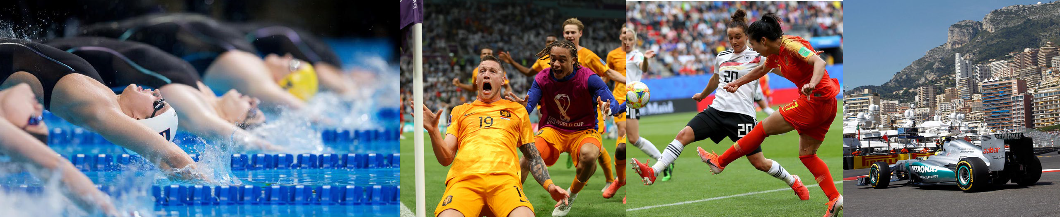

**For reservations & inquiries, call Les Clem 1.513-963-5303 or visit https://peopleplace.com**

# Calendar of Sporting Events



Custom Sports Travel Packages Including Your Preferred:

Dates of travel • Level of hotel • Event seating • At-Your-Service Pre-Travel Desk to handle all additional needs • Plus many more optional add-ons

|  |  |  |  |
| --- | --- | --- | --- |
| **Event** | **Venue** | **Destination** | **Date** |
| 2024 US Open Tennis | National Tennis Center | New York, NY | August 26 - September 8, 2024 |
| 2024 Italian Grand Prix | Autodromo Nazionale Monza | Milan, Italy | August 29 - September 2, 2024 |
| 2024 Singapore Grand Prix | Marina Bay Street Circuit | Singapore | September 19-23, 2024 |
| 2024 Presidents Cup | Royal Montreal Golf Club | Montreal, Quebec | September 25-30, 2024 |
| 2024 US Grand Prix | Circuit of the Americas | Austin, TX | October 17-21, 2024 |
| 2024 World Series | TBD | TBD | October 27 - November 1, 2024* |
| 2024 Las Vegas Grand Prix | Las Vegas Street Circuit | Las Vegas, NV | November 20-24, 2024 |
| 2024 Abu Dhabi Grand Prix | Yas Marina Circuit | Abu Dhabi, UAE | December 5-9, 2024 |
| 2025 Rose Bowl | Rose Bowl | Pasadena, CA | December 30, 2024 - January 2, 2025 |
| 2025 Australian Open | Melbourne Park | Melbourne, Australia | January 12-26, 2025 |
| 2025 Super Bowl | Caesars Superdome | New Orleans, LA | February 6-10, 2025 |
| 2025 Daytona 500 | Daytona International Speedway | Daytona, FL | February 12-17, 2025 |
| 2025 Men's Final Four | Alamodome | San Antonio, TX | April 4-8, 2025 |
| 2025 Masters | Augusta National Golf Club | Augusta, GA | April 7-13, 2025 |
| 2025 Kentucky Derby | Churchill Downs | Louisville, KY | May 1-4, 2025 |
| 2025 Miami Grand Prix | Miami International Autodrome | Miami, FL | May 1-5, 2025 |
| 2025 Monaco Grand Prix | Monte Carlo Street Circuit | Monte Carlo, Monaco | May 22-26, 2025 |
| 2025 Indy 500 | Indianapolis Motor Speedway | Speedway, IN | May 23-26, 2025 |
| 2025 French Open | Roland Garros | Paris, France | May 25 - June 8, 2025 |
| 2025 Champions League Final | Allianz Arena | Munich, Germany | May 29 - June 1, 2025 |
| 2025 Spanish Grand Prix | Circuit de Barcelona-Catalunya | Barcelona, Spain | May 29 - June 2, 2025 |
| 2025 Stanley Cup Finals | TBD | TBD | June 2025* |
| 2025 US Open Golf | Oakmont Country Club | Oakmont, PA | June 12-15, 2025 |
| 2025 Canadian Grand Prix | Circuit Gilles Villeneuve | Montreal, Quebec | June 12-16, 2025 |
| 2025 Wimbledon Championships | All England Lawn Tennis Club | London, England | June 30 - July 13, 2025 |
| 2025 MLB All-Star Game | Truist Park | Atlanta, GA | July 13-16, 2025 |
| 2025 Ryder Cup | Bethpage Black Course | Farmingdale, NY | September 22-28, 2025 |
| 2026 Super Bowl | Levi's Stadium | San Francisco Bay Area, CA | February 6-9, 2026 |
| 2026 Winter Games | Various Venues | Milan and Cortina, Italy | February 6-22, 2026 |
| 2026 World Cup | Various Venues | USA, Mexico, Canada | June 11 - July 19, 2026 |
| 2027 Super Bowl | SoFi Stadium | Los Angeles, CA | February 11-15, 2027 |
| 2027 Women's World Cup | Various Venues | Brazil | June 24 - July 25, 2027 |
| 2027 Basketball World Cup | Various Venues | Qatar | August 27 - September 12, 2027 |
| 2027 Rugby World Cup | Various Venues | Australia | October 1 - November 13, 2027 |
| 2028 Summer Games | Various Venues | Los Angeles, CA | July 14-30, 2028 |

*TBD **For reservations & inquiries, call Les Clem 1.513-963-5303 or visit https://peopleplace.com**